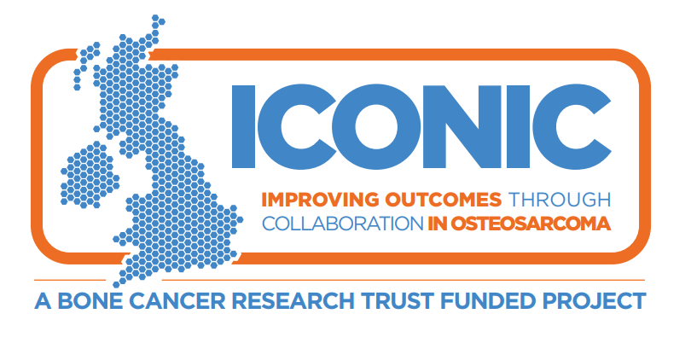
Information about a research study
for patients aged 6-9 years
To be shown to and read by parent or carer if required

ICONIC Study:
This is a study to learn more about osteosarcoma, which is a type of bone cancer, to help make new and better treatments.

Hello,
A group of your doctors would like to ask for your help in doing some research to try and find out more about osteosarcoma and how to make someone like you better when they are ill.
We will ask your mum, dad or carer if you can take part in this study. We also want to tell you about the study to see if you want to be in it. You can talk to your mum, dad or carer and doctors as well and ask them any questions you want to ask.

Why have I been chosen?
- You have been chosen because you have a tumour (growth) called osteosarcoma that is a kind of bone cancer.
- We want to learn more about it and how patients like you do on treatment.
- We want to collect some facts about you and your tumour growth and use some blood from you so that we can do tests in a laboratory that could help us learn more about osteosarcoma.
- This study does not give you any new medicines so you will have the same medicines from your doctors if you join the study or not.

Do I have to be in it?
No, it’s up to you and your mum, dad or carer to choose if you want to join this study.

What will happen to me if I join in?

- We’ll collect information about your tumour which your doctor has just found and the care that you receive for it.

- We’ll take some extra bloods. We’ll try and take these at the same time as we take other blood so you won’t have any extra jabs.

- We’ll take some extra tissue from your tumour during your usual care.

- You won’t have to make any extra visits to your hospital if you’re in this study.

Will being in this study make me unwell?
This study does not have a new drug treatment so you’ll get the same care from your doctors if you join in this study or not.
If you have any questions please ask your mum, dad or carer or your doctor.
