[INSERT TRUST HEADER HERE]

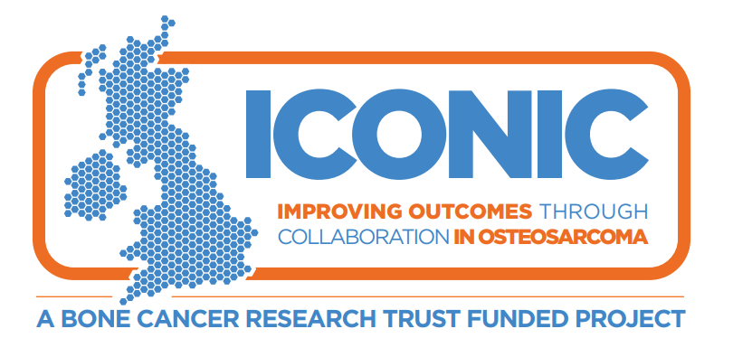
Information about a research study
(for patients aged 10 – 12 years)

ICONIC Study:
This is a research study to understand more about osteosarcoma, which is a type of bone cancer, and develop new and better treatments.

Hello,
A group of doctors would like to ask for your help in doing some research to try and find out more about osteosarcoma and how to make children better when they are ill.
We will ask your parents (or carer) if you can take part in this study. We also want to describe the study to you to see if you want to take part in it. You can talk to your parents (or carer) and doctors and ask any questions you may have.

Why have I been chosen?
- You a have a tumour (growth) called osteosarcoma which is a type of bone cancer.

- We want to understand more about this disease and how patients respond to treatment.
- We want to collect information about you and take some of your tumour and blood so that we can run tests in a laboratory which may help us to learn more about osteosarcoma.
- This study does not involve any new medicines so you will have the same medicines from your doctors whether you join the study or not.

Do I have to take part?
No, it’s up to you and your parents (or carer) to decide whether to join this study.

What will happen to me if I take part?

- We will collect information about your tumour that your doctor has recently found and the treatment that you receive.

- We will take some extra bloods. We will try and take these at the same time as we take other blood so you won’t need any extra jabs.

- We will take some extra tissue from your tumour during routine procedures.

- We would also like to collect some of your tumour if your cancer comes back or spreads after treatment. This may need an extra biopsy but this is optional so you do not have to have the extra biopsy if you don’t want to.

- You do not have to make any extra visits to the hospital if you take part in this study unless you agree to have an extra biopsy.

Will taking part in this study make me unwell?
This study does not involve a new drug treatment so you will receive the same care from your doctors whether you take part in this study or not.
If you have any questions please speak to your parents (or carer) or your doctor.

