(INSERT HOSPITAL/INSTITUTION LOGO HERE)
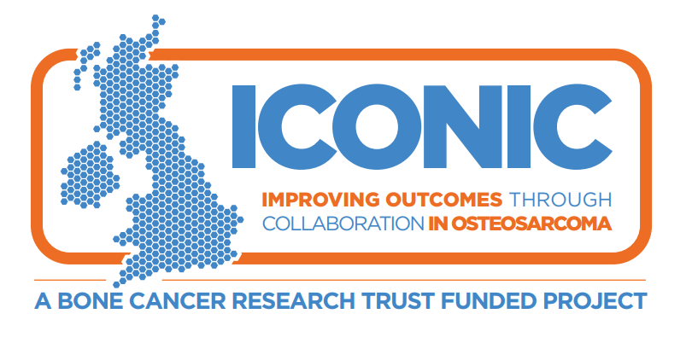

Information for parents and guardians about a research study

Invitation and Summary
We are asking your child to join this research study because your child has recently been diagnosed with osteosarcoma or a similar bone cancer. We understand that this may be a very challenging time for you and yours but were wondering whether you would be interested in helping us better understand treatments for people in your child’s situation.
We are committed to learning more about osteosarcoma so that we can develop new treatments and to design better clinical trials to test for new treatments. Ultimately our aim is to help osteosarcoma patients live better and longer lives.

This study is simply observational so we are not testing any new drug treatments, as such there will be no change to the standard treatment your child receives. For this study we would like to:
- collect clinical information about your child’s diagnosis and their treatment for osteosarcoma by accessing your child’s medical records
- collect blood samples and tumour tissue samples at selected time points as detailed below
- if your child is less than 13, ask you to complete a questionnaire on study entry on their behalf
- if your child is aged 13 or over, ask your child to complete some questionnaires at selected time points
- ask if we can take a genetic test from your child

Genetic testing is an important aspect of the study. If you or your child do not want to have any genetic testing, unfortunately they cannot take part in the study. There is more information about what is involved in taking part later in this Patient Information Sheet. Your child will also be given an information sheet explaining the study.

Whilst your child may not benefit directly from this research, their participation may help patients in the future by improving treatments of osteosarcoma.

To help you understand why this study is important so that you and your child can decide whether to take part, we have put together this information which may help you make a more informed decision. We would like to encourage you to please take time to read the remaining information carefully and perhaps talk to your child, and discuss the study with others if you want. We hope you will find this information sheet helpful, but we understand it may not answer all your or your child’s questions. We are here to help you so please don’t hesitate to call us on the phone number at the end of this information sheet.

We are inviting your child to take part in a research study
- You and your child are free to choose whether or not your child should take part in this research study. If you choose that they do not to take part, this will not affect the standard of care your child receives in any way.
- If you and your child decide to take part, if they want we will ask your child to sign assent to show that they have agreed to take part. As your child is under the age of 16 you will also be required to sign the consent form.
- You and/or your child can decide to stop taking part in the study at any time without giving a reason.

Why are we conducting this research study?
- We want to understand more about
what causes osteosarcoma and how osteosarcoma changes with treatment and over time. This will help us to decide what types of treatment are likely to work best, allowing us to develop better clinical trials of new treatments.
- Ultimately our aim is to help osteosarcoma patients live better and longer lives.

Important things you need to know about this research study
- This is an observational study.
It is not a study looking at a new treatment. Taking part in this study will not stop your child from taking part in a study of a new treatment if this is an option for them.
- For our study we will take extra blood samples at up to 12 different times in addition to routine blood tests. Where possible, these will be taken when your child has their routine bloods so no additional visits should be required.
- We may ask for your child to have a biopsy that they wouldn’t have routinely. This biopsy is optional and you with your child don’t need to agree to the extra biopsy to take part in the study. This is entirely up to you and your child.
- We’ll ask your child to complete some questionnaires about their health and wellbeing, with your help if necessary. This is something that your child wouldn’t need to do if they weren’t on the study.

Will your child have to visit hospital more often if they take part?
- Your child does not have to make any extra visits to the hospital if you take part in this study unless you with your child agreed to have the extra biopsy.

Thank you
Thank you for reading this information.
If your child takes part, your child will help us understand more about osteosarcoma and its treatment and this may help future people with osteosarcoma.

Contents
1. Why are we doing this study? 4
2. Why are we asking your child to take part? 5
3. What will happen if your child takes part? 5
4. Are there any risks? 7
5. What are the possible advantages and disadvantages of taking part? 7
6. Does your child have to take part? 8
7. How will your child’s information be used – will it be kept confidential? 8
8. Who is organising and funding the research? 8
9. Who has reviewed the study? 9
10. How will your child’s data be handled during the study? 9
11. Who will your child’s study data be shared with? 9
12. What will happen to the samples your child gives? 9
13. Will any genetic tests be done? 10
14. How long will the study last? 10
15. What will happen if you or your child don’t want to carry on with the study? 10
16. What would happen if your child lost capacity whilst on the study? 10
17. What if there is a problem? 11
18. What will happen to the results of the research study? 11
19. Study Flow chart 13
20. Samples schedules 14
21. Your treatment team’s contact details 15

Why are we doing this study?
There hasn’t been much improvement in outcome for patients with osteosarcoma over the last 20 years. There have been only a few clinical trials of new treatments and no major new therapies introduced recently.
This is in part because we do not have a good understanding of the biology of osteosarcoma, but also trials have only included small numbers of patients. The more we understand about how and why osteosarcoma happens, the better we will be able to decide what treatments are most likely to work best.
We are doing this study to collect high quality clinical data about osteosarcoma patients of all ages – such as information about the size of the disease and where it is at diagnosis, what treatments were given and how osteosarcoma responds to treatments. We will also collect blood and tissue samples for analysis in research laboratories.
By looking at the results of the laboratory findings and the clinical data together, we will start to answer questions about why osteosarcomas arise and grow, what makes them spread and why some patients respond to treatment better than others.
We plan to use this information to develop clinical trials of new treatments.
Also, we want to find out more about how osteosarcoma and its treatments affect the lives of people with this disease. This will help us provide the most appropriate care and support to meet the needs of each patient.
Ultimately, our aim is to improve the care and treatment of osteosarcoma patients so that they may live longer and better lives.

Why are we asking your child to take part?
Your child has been invited to take part in this study because they have had a recent diagnosis of osteosarcoma.
We want to recruit as many patients to the study as possible and are recruiting patients of all ages from hospitals across the UK.
We hope to have at least 350 patients at the end of the study and we will be recruiting for around two more years.

What will happen if your child takes part?

Treatment
If you and your child decide to take part in this study, your child will receive routine treatment for their osteosarcoma. Depending on your child’s treatment plan, they may have one or more of the following:
- Surgery
- Chemotherapy
- Radiotherapy
As part of their routine care, we will explain what treatment your child will receive. Your child’s treatment will not be affected by taking part in this study.

Tests and investigations
Your child will have all the routine tests and investigations that they would have even if they weren’t taking part in this study. These include blood tests, scans and biopsies if required.
If your child takes part, they will have some extra tests and investigations. These are described below. The number and timing of the extra samples depend on your child’s treatment pathway.
If your child takes part, we will monitor your child at least annually according to routine practice for up to two years. After this, we may continue to collect routine clinical data from their medical records (long term follow up) but your child won’t need to attend any study specific visits for this.
We have a flow chart showing the different treatment pathways at the end of this information sheet.

Blood Samples
We will always aim to take the study samples at the same time your child is having routine blood samples taken so that no extra jabs are required. We will aim to take a minimum of 5ml for each sample if possible.
Germline DNA:
We will take one blood sample to look at your child’s genome – this is the complete set of all their genetic code - so we can find patterns in their genes that are linked to your child’s osteosarcoma.
Circulating Tumour Cells (CTCs):
We will take these blood samples if your child is having chemotherapy before surgery. CTCs are cells that break off from the tumour into the blood stream and we want to look to see if we can identify these cells in blood and use them to monitor how patients with osteosarcoma respond to treatment.
We will take these samples at the following time points:
- Before your child starts chemotherapy.
- After chemotherapy, before your child has surgery (if this is part of their treatment).
- If your child’s cancer comes back or spreads after treatment.
Circulating Tumour DNA (ctDNA):
With your consent we will take these samples to look at the DNA released from tumour cells into the blood stream, to see if we can link it to how patients with osteosarcoma respond to treatment.
We will take these samples at the following time points:

- Before, or shortly after, your child starts their chemotherapy
- After chemotherapy, before your child has surgery (if this is part of their treatment)
- At the end of your child’s treatment
- Routine follow up clinic visits, no more than 6 monthly, after that.
- If your child’s cancer comes back or spreads after treatment.
These will be optional so you and your child do not have to consent to these blood samples if you or your child don’t want to.
[UCLH to include the following blue text. All other sites to delete]
Peripheral blood mononuclear cells (PBMCs):
These cells are part of your immune system and are primed to recognise and destroy cells which do not belong to you. If you consent we will take these samples for immune studies and to see if we can link them to how patients with osteosarcoma respond to treatment.
We will take these samples at the following time points:
- Before, or shortly after, your child starts chemotherapy.
- After chemotherapy, before your child has surgery (if this is part of their treatment).
- At the end of your child’s treatment
- If your child’s cancer comes back or spreads after treatment.
We will collect these additional blood samples in about 20 patients taking part in the ICONIC study. These will be optional so you do not have to consent to your child donating these blood samples if you or your child don’t want to.
Over the course of the study we may take bloods at up to 12 time points. In total, this will be a minimum of around 60mL of blood.
The amount of blood that we take will not affect your child in any way.
We would also like your consent to store any remaining blood samples for use in future research, but you do not have to consent to this if you or your child don’t want to.

Tissue samples and biopsies
We will collect tissue samples for use in this study at the time of your child’s diagnosis and their surgery. The tissue will be removed during routine procedures so your child will not have to have any extra procedures for this.
We would also like to collect some tissue if your child’s cancer comes back or spreads after treatment. We would use this to look at gene changes in osteosarcoma.
Your child might not normally have a routine procedure to remove tissue at this time. In this case, we would ask for your consent for your child to have an extra biopsy. The extra biopsy is also optional so your child does not have to have the extra biopsy if you or your child do not want it.
The type of imaging used to help to collect this biopsy will be decided by your child’s doctor who will discuss any potential risks with you and your child before you and your child decide to have the biopsy.

Questionnaires
If your child is aged 13 years or more we
will ask your child to complete some questionnaires about their symptoms, diagnosis, health and general wellbeing. It should take no more than 40 minutes to complete all the questionnaires. We will give the questionnaires:
- At study entry
- At the end of treatment (not applicable if treatment not given for any reason)
- At 12, 24, 36 and 48 months.
If your child is aged 13 years or more we will also ask your child to complete a separate questionnaire shortly after they start treatment. This questionnaire aims to gain a better understanding of their pathway, from symptoms and diagnosis to treatment for people with osteosarcoma. If your child is less than 13 years old we will ask you to complete this form instead. If you agree to complete these, we will be able to see changes in quality of life due to osteosarcoma, research into the osteosarcoma patient experiences and look into the process of diagnosis for osteosarcoma. In addition, and with your consent, we will also ask your child’s GP to complete a parallel questionnaire.

Data collection
With your and your child’s permission we will collect data from your child’s medical records about their general health, their cancer, their treatment and investigations including routine blood tests and scans. We will pass this information on to Cancer Research UK & UCL Cancer Trials Centre (UCL CTC), which is the organisation running the study. See Section 7 for more information about how your child’s data will be handled.

Scan images
We would like to collect the images from any routine scans your child has, such as CT, MRI or bone scans. They will be sent to a team at UCL. We will use these to learn more about the different types of scans patients across the UK are having to diagnose their osteosarcoma.
We will see if we can learn more about osteosarcoma by linking the information from these scans to the results from your child’s blood and tissue analyses and data collected from their medical records.
Only your child’s initials and study number will be marked on any scan images sent. This is to make sure that it will not be possible to identify your child and make sure their scan images are not mixed up with those from other patients. The researchers will make sure your child’s information is held securely and not shared with anyone else. See Section 10 below for more information on how your data is handled.

Are there any risks?
Your child may have an extra biopsy for this research. Biopsies may be painful and carry a risk of infection. As mentioned, this extra biopsy is optional.

What are the possible advantages and disadvantages of taking part?

Advantages
Your child will not benefit directly from taking part in this study. However, by taking part, your child will help us to understand more about osteosarcoma, and this may help future patients.

Disadvantages
There are very few disadvantages to taking part. Your child may need to spend a bit of extra time at the hospital when he/she visits for their appointments to complete the study questionnaires or have the extra blood tests.
It is possible your child may have extra jabs if, for some reason, we cannot take the research blood samples at the same time as their routine blood tests.
If your child has an extra biopsy for research, they may need to come for an extra visit.

Does your child have to take part?
No, this is up to you and your child.
We will go through this information sheet with you and answer any questions that you have. If you and your child decide to take part we will ask you to sign the consent form to show you have agreed for your child to take part in the study. Your child can also sign their assent on the consent form if they would like to.
You and your child are free to withdraw from the study at any time, without giving a reason. If you or your child decide not to take part, or later withdraw from the study, this will not affect the standard of care your child receives.

How will your child’s information be used – will it be kept confidential?
University College London (UCL) is the Sponsor and Data Controller for this study and it is run on their behalf by Cancer Research UK & UCL Cancer Trials Centre (UCL CTC), based in the United Kingdom. UCL CTC will be using information from your child and their medical records to undertake this study. This means that UCL CTC are responsible for looking after your child’s information and using it properly. UCL CTC will keep identifiable information about your child for at least 5 years after the study has finished.
Details about your child and their treatment and how the cancer responds will be recorded in your child’s medical notes. This research is conducted in the public interest as it may lead to improvements in future treatment.
Your and your child’s rights to access, change or move their information are limited, as UCL CTC need to manage your child’s information in specific ways so that the research is reliable and accurate. If your child withdraws from the study, UCL CTC will keep information about your child that they have already obtained. To safeguard your child’s rights, UCL CTC will
use the minimum personally identifiable information possible.
You can find out more about how UCL CTC will use your child’s information on UCL CTC’s website: https://www.ctc.ucl.ac.uk/Privacy.aspx
If you want to raise a complaint on how UCL CTC have handled your child’s personal data, you can contact the UCL Data Protection Officer who will investigate the matter. If you are not satisfied with their response or believe they are processing your child’s personal data in a way that is not lawful you can complain to the Information Commissioner’s Office (ICO).
UCL’s Data Protection Officer can be contacted on data-protection@ucl.ac.uk.

Who is organising and funding the research?
The study is funded by the Bone Cancer Research Trust (BCRT), a charity dedicated to fighting primary bone cancer. The study is being run by UCL CTC.
The hospital where your child will be treated will receive a payment to help cover the costs of this research (extra biopsies and blood tests). However, your child’s doctor will not be paid for including your child in this study.

Who has reviewed the study?
All research in the NHS is looked at by an independent group called a Research Ethics Committee to protect the interests of any patients who may take part. This study has been reviewed and granted a favourable opinion by the London – Camden and King’s Cross Research Ethics Committee (REC) and has also been approved by the Health Research Authority (HRA).

How will your child’s data be handled during the study?
When your child joins the study UCL CTC will assign a study number to them, which will
be used instead of their name and will be linked to all their study data. This is called ‘pseudonymised data’: your child cannot be directly identified from this.
We will also pass your child’s initials, age and sex to UCL CTC along with the information collected from your child and their medical records. Your child’s initials and study number will also be marked on any blood samples, tissue samples, images and pathology reports you and your child agree to being collected and sent to laboratories in the UK analysing these samples as part of this study. This is to make sure that your child’s samples are not mixed up with those from other patients. The laboratories will make sure your child’s information is held securely and not shared with anyone else.
Your child’s medical records may also
be looked at by appropriate individuals from UCL CTC, UCL or its representatives, regulatory authorities and your NHS Trust or Health Board. This is to ensure that the study is being carried out properly and the information collected is accurate. The appropriate individuals may compare the recorded research data with your child’s health records. They might read your child’s health records though a secure internet connection or at the hospital or clinic. All the computers storing patient data must meet special security arrangements.
Your child’s name or identifiable data will not be used in any reports about the study.

Who will your child’s study data be shared with?
When you and your child agree to take part in this research study, the information about your child’s health and care may be provided to researchers running other research studies in UCL and other organisations, such as universities, the NHS, or companies involved in health and care research in the UK or abroad. Your child’s information will only be used in research that has been independently reviewed by an Ethics Committee and is conducted in accordance with the UK Policy Framework for Health and Social Care Research.
UCL CTC will not share any information that can identify your child, or that can be combined with other information in a way that could directly identify your child, however we may share your child’s study number. The information will only be used for the purpose of health care research and cannot be used to contact your child or affect your child’s care. Information about your child will not be used to make decisions about future services available to your child, such as insurance.

What will happen to the samples your child gives?

Blood and tissue samples collected for research
The blood and tissue samples collected for research will be sent to laboratories in the UK, and possibly outside the UK. They will be used for research to help scientists learn more about osteosarcoma. This includes trying to find ways to predict who is going to respond to treatment, understanding more about what causes osteosarcoma to grow and how the cells may change after treatment.

Future research
We would like your and your child’s consent to store some of your child’s tissue and the blood samples for use in future research projects. Any future research involving your child’s stored tissue or blood samples will take place only after it has received appropriate Ethical approval.
If you or your child do not want to give permission for the use of your child’s tissue and blood samples in future research, your child can still participate in this study.

Will any genetic tests be done?
Yes: Genetic testing is an important part of this research.
We will ask you and your child to consent specifically to have genetic testing. If you or your child do not want to have any genetic testing, your child will not be able to take part in the study.
Results of genetic tests may include chance findings about your child’s health, or your health and that of their blood relatives. For instance, the tests may show that your child has a genetic mutation putting them at greater risk of developing another cancer, and that you and your blood relatives could have this mutation as well.
You and your child can tell us on the consent form whether or not you or your child want us to tell you about any chance findings for your child and their blood relatives.
However, we will always tell you and your child about any findings that could affect the way we treat your child’s cancer.
If we do tell you and your child about a chance finding, we will refer you and your child (and your family if necessary) to a genetic counsellor who will give you information and advice.

14. How long will the study last?
This study has approval to last for two years.
If further funding becomes available after this time we would like to continue to collect your child’s routine clinical data and pass this to UCL CTC.
This means your child’s participation in the study will be from the time you enter the study until the time the study ends: up to two years but possibly longer if the study is extended.

What will happen if you or your child don’t want to carry on with the study?
You and your child can withdraw from the study at any time without giving a reason and without your child’s rights being affected, but UCL CTC would like to continue to collect information about your child, so that they know about your child’s progress. They will also use the information collected up to your child’s withdrawal.
Any stored blood or tissue samples that can be identified as your child’s will be destroyed if you or your child want.

What would happen if your child lost capacity whilst on the study?
If your child lost capacity, that is, where your child loses the ability to make decisions or
to communicate their decisions whilst on
the study, we would make sure your child continues to receive the most appropriate care and treatment.
We would keep all the information already collected about your child for the study. We would plan to continue to collect information for the purposes of the study unless we had any reason to believe that you or your child would not agree to this. This is because it is really important to have as much information as possible about all of the patients taking part in the study to make sure the results are reliable. We would talk to you about this and carefully consider any request you may make to withdraw your child from the study.

What if there is a problem?
Every care will be taken in the course of this study. However, in the unlikely event that your child is injured by taking part, compensation may be available.
If you suspect that the injury is the result of the Sponsor’s (University College London) or the hospital's negligence, then you may be able to claim compensation. After discussing with your child’s study doctor, please make the claim in writing to Dr Sandra Strauss, who is the Chief Investigator for the study, and is based at University College London, c/o ICONIC Trial, Cancer Research UK & UCL Cancer Trials Centre, 90 Tottenham Court Road, London, W1T 4TJ. The Chief Investigator will then pass the claim to the Sponsor and on to the Sponsor’s Insurers. If you have a claim then it might be helpful to consult a lawyer.
Participants may also be able to claim compensation for injury caused by participation in this study without the need to prove negligence on the part of University College London or another party. You should discuss this possibility with your child’s study doctor in the same way as above.
Regardless of this, if you want to complain or have any concerns about any aspect of the way your child has been approached or treated
by members of staff due to your child’s participation in the study, the normal National Health Service complaints mechanisms are available to you. Please ask your child’s study doctor if you would like more information on this. Details can be obtained from the NHS website.

What will happen to the results of the research study?
The results of the study will be published in medical journals. Your child’s identity and any personal details will be kept confidential. No named information about your child will be published in any report of the study. Once the results of the study have been published they will also be available to the public on the internet.
We will have a summary of the results which we can give to you and your family or child’s carers. We would also be happy to explain the results of the study to you and your child and to answer any questions you and your child have.

Thank You
Thank you for taking the time to read this leaflet and to consider this study.
Please discuss any questions you or your child may have with us. Contact details are given at the end of this sheet, if you would like to discuss any aspect of the study further. There is also space at the end of the Patient Information Sheet for you to write down questions/comments that occur to you as you read about the study.

Further Information
You may want to contact one of the following organisations that are independent of the hospital where your child is being treated:

Cancer Research UK
Cancer Research UK provides information for people with cancer. Their contact details are:
Freephone: 0808 800 4040 (Mon-Fri 9am-5pm)
Or visit their website at:
https://www.cancerresearchuk.org/about-cancer

Macmillan Cancer Support
Macmillan is a charity which provides support and counselling to help people live with cancer. They can be contacted at:
Freephone: 0808 808 0000 (8am-8pm, seven days a week)
https://www.macmillan.org.uk/information-and-support

Bone Cancer Research Trust
The Bone Cancer Research Trust is the leading charity dedicated to fighting primary bone cancer. Their mission is to save lives and improve outcomes for people affected by primary bone cancer through research, information, awareness and support.
https://www.bcrt.org.uk/information/

If you and your child decide your child would like to take part then please read and sign the consent form. You will be given a copy of this information sheet and the signed consent form to keep. You and your child can have more time to think this over if you are at all unsure.

Study Flow chart

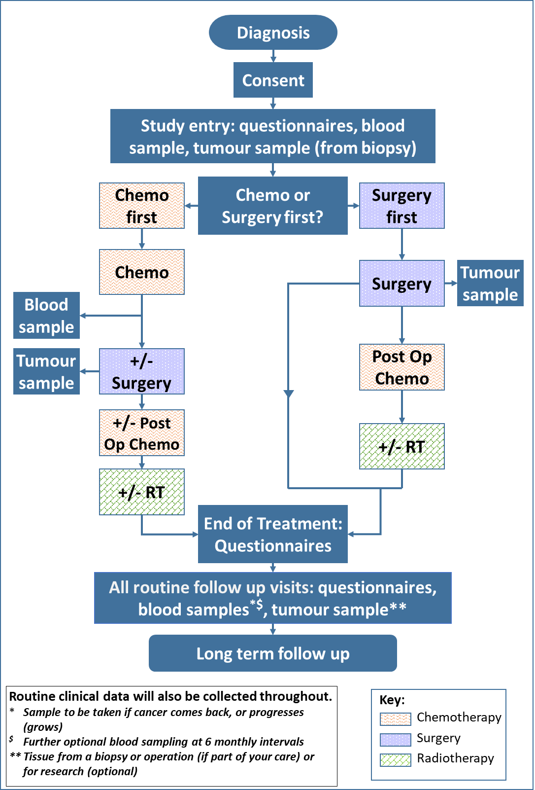

Samples schedules

Samples schedule:  If your child is receiving surgery, with or without chemotherapy afterwards | Up to four weeks after registration | At Surgery | End of Treatment | Follow ups | If the osteosarcoma comes back or spreads after treatment
Germline DNA Blood sample | Yes
ctDNA blood sample - Optional | Yes |  | Yes | Yes ¹ | Yes
FFPE tumour tissue sample | Yes | Yes |  |  | Yes²
Frozen tissue samples |  | Yes |  |  | Yes²
- Will be collected at clinic visits during follow up - no more than 6 monthly.
- Will only be taken if you and your child consent to this optional biopsy (if this is not collected as part of their treatment).

Samples schedule:  If your child is receiving chemotherapy before surgery | Up to four weeks after registration | During Treatment |  | End of Treatment | Follow ups | If the osteosarcoma comes back or spreads after treatment
 |  | At the end of Neoadjuvant chemo | At Surgery
Germline DNA Blood sample | Yes
CTC blood sample | Yes | Yes | (Yes)¹ |  |  | Yes
ctDNA blood sample - Optional | Yes | Yes | (Yes)¹ | Yes | Yes² | Yes
PBMCs blood sample (UCLH patients only) | Yes | Yes | (Yes)¹ | Yes |  | Yes
FFPE tumour tissue sample | Yes |  | Yes |  |  | Yes³
Frozen tissue samples | Yes |  |  |  |  | Yes³
- Will be collected before surgery - if not taken at end of the chemotherapy before surgery
- Will be collected at clinic visits during follow up - no more than 6 monthly.
- Will only be taken if you and your child consent to this optional biopsy (if this is not collected as part of their treatment).

Your treatment team’s contact details

Your child’s doctor:
Phone number:
Your child’s research/ specialist nurse:
Phone number:

Questions/Comments
The space below is for you to write down any questions you would like to ask your child’s Doctor or Research Nurse about taking part in the study

