(INSERT HOSPITAL/INSTITUTION LOGO HERE)

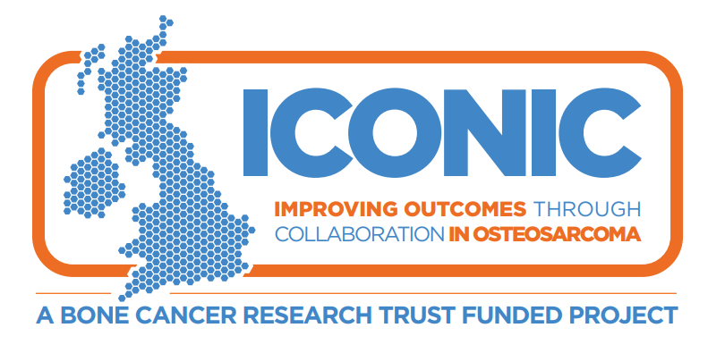

Information about a research study

Invitation and Summary
We are asking you to join this research study because you have recently been diagnosed with osteosarcoma or a similar bone cancer. We understand that this may be a very challenging time for you and yours but were wondering whether you would be interested in helping us better understand treatments for people in your situation.
We are committed to learning more about osteosarcoma so that we can develop new treatments, and design better clinical trials to test for new treatments. Ultimately our aim is to help osteosarcoma patients live better and longer lives.

This study is simply observational so we are not testing any new treatments, as such there will be no change to the standard treatment you receive. For this study we would like to:
- collect clinical information about your diagnosis and treatment for osteosarcoma by accessing your medical records collect blood samples and tumour tissue samples at selected time points as detailed below
- ask you to complete some questionnaires at selected time points
- ask you to take a genetic test

Genetic testing is an important aspect of the study so that we can look at the role that genetics play in responding to different treatments. If you do not want to have any genetic testing, unfortunately you cannot take part in the study. There is more information about what is involved in taking part later in this Patient Information Sheet.

Whilst you may not benefit directly from this research, your participation may help patients in the future by improving treatments of osteosarcoma.

To help you understand why this study is important so that you can decide whether to take part, we have put together this information which may help you make a more informed decision. We would like to encourage you to please take time to read the remaining information carefully and perhaps talk to others about the study if you want. We hope you will find this information sheet helpful, but we understand it may not answer all your questions. We are here to help you so please don’t hesitate to call us on the telephone number at the end of this information sheet.

We are inviting you to take part in a research study:
- You are free to choose whether or not
you want to take part in this research study. If you choose not to take part, this will not affect the standard of care you receive in any way.
- You can decide to stop taking part in the study at any time without giving a reason.

Why are we conducting this research study?
- We want to understand more about
what causes osteosarcoma and how osteosarcoma changes with treatment and over time. This will help us to decide what types of treatment are likely to work best, allowing us to develop better clinical trials of new treatments.
- Ultimately our aim is to help osteosarcoma patients live better and longer lives.

Important things you need to know about this research study.
- This is an observational study.
It is not a study looking at a new treatment. Taking part in this study will not stop you from taking part in a study of a new treatment if this is an option for you.
- For our study we will take extra blood samples at up to 12 different times in addition to your routine blood tests. Where possible, these will be taken when you have your routine bloods so no additional visits should be required.
- We may ask you to have a biopsy that you wouldn’t have routinely. This biopsy is optional and you don’t have to agree to the extra biopsy to take part in the study. This is entirely up to you.
- We’ll ask you to complete some questionnaires about your health and wellbeing. This is something that you wouldn’t need to do if you weren’t on the study

Will you have to visit hospital more often if you take part?
- You do not have to make any extra visits to the hospital if you take part in this study. The only exception would be if you agreed to have the extra biopsy.

Thank you
- Thank you for reading this information.
If you take part, you will help us to understand more about osteosarcoma and its treatment and this may help future people with osteosarcoma.

Contents
1. Why are we doing this study? 3
2. Why are we asking you to take part? 4
3. What will happen if you take part? 4
4. Are there any risks? 6
5. What are the possible advantages and disadvantages of taking part? 6
6. Do you have to take part? 7
7. How will your information be used – will it be kept confidential? 8
8. Who is organising and funding the research? 8
9. Who has reviewed the study? 8
10. How will your data be handled during the study? 8
11. Who will your study data be shared with? 9
12. What will happen to the samples you give? 9
13. Will any genetic tests be done? 9
14. How long will the study last? 10
15. What will happen if you don’t want to carry on with the study? 10
16. What would happen if you lost capacity whilst on the study? 10
17. What if there is a problem? 10
18. What will happen to the results of the research study? 11
19. Study Flow chart 12
20. Samples schedules 13
21. Your treatment team’s contact details 14

Why are we doing this study?
There hasn’t been much improvement in outcome for patients with osteosarcoma in over 20 years. There have been only a few clinical trials of new treatments and no major new therapies introduced recently.
This is in part because we do not have a good understanding of the biology of osteosarcoma, but also trials have only included small numbers of patients. The more we understand about how and why osteosarcoma happens, the better we will be able to decide what treatments are most likely to work best.
We are doing this study to collect high quality clinical data about osteosarcoma patients of all ages, such as information about the size of the disease and where it is at diagnosis, what treatments were given and how osteosarcoma responds to treatments. We will also collect blood and tissue samples for analysis in research laboratories.
By looking at the results of the laboratory findings and the clinical data together, we will start to answer questions about why osteosarcomas arise and grow, what makes them spread and why some patients respond to treatment better than others.
We plan to use this information to develop clinical trials of new treatments.
Also, we want to find out more about how osteosarcoma and its treatments affect the lives of people with osteosarcoma. This will help us provide the most appropriate care and support to meet the needs of each patient.
Ultimately, our aim is to improve the care and treatment of osteosarcoma patients so that they may live longer and better lives.

Why are we asking you to take part?
You have been invited to take part in this study because you have had a recent diagnosis of osteosarcoma.
We want to recruit as many patients to the study as possible and are recruiting patients of all ages from hospitals across the UK.
We hope to have at least 350 patients at the end of the study and we will be recruiting for around two years.

What will happen if you take part?

Treatment
If you decide to take part in this study, you
will receive routine treatment for your osteosarcoma. Depending on your treatment plan, you may have one or more of the following:
- Chemotherapy
- Surgery
- Radiotherapy
As part of your routine care, we will
explain what treatment you will receive. Your treatment will not be affected by taking part in this study.

Tests and investigations
You will have all the routine tests and investigations that you would have even if you weren’t taking part in this study. These include blood tests, scans and biopsies if required.
If you take part, you’ll have some extra tests and investigations. These are described below. The number and timing of extra samples depends on your treatment pathway.
If you choose to be part of this study we will monitor you at least annually according to routine practice for up to two years. After this, we may continue to collect routine clinical data from your medical records (long term follow up) but you won’t need to attend any study specific visits for this.
We have a flow chart showing the different treatment pathways at the end of this information sheet.

Blood Samples
We will always aim to take study samples at the same time you are having routine blood samples so no extra needles are required.
Germline DNA: We will take one blood sample to look at your genome – this is the complete set of all your genetic code - so we can find patterns in your genes that are linked to your osteosarcoma.
Circulating Tumour Cells (CTCs): We will take these blood samples if you are having chemotherapy before surgery. CTCs are cells that break off from the tumour into the blood stream and we want to look to see if we can identify these cells in blood and use them to monitor how osteosarcoma patients respond to treatment.
We will take these samples at the following time points:
- Before you start your chemotherapy.
- After chemotherapy, before you have surgery (if this is part of your treatment)
- If your cancer comes back or spreads after treatment.
Circulating Tumour DNA (ctDNA): With your consent we will take these samples to look at the DNA released from tumour cells into the blood stream, to see if we can link it to how patients with osteosarcoma respond to treatment.
We will take these samples at the following time points:
- Before, or shortly after, you start your chemotherapy.
- After chemotherapy, before you have surgery (if this is part of your treatment)
- At the end of your treatment,
- Routine follow up clinic visits, no more than 6 monthly, after that.
- If your cancer comes back or spreads after treatment.
These will be optional, so you do not have to consent to these blood samples if you don’t want to.
[UCLH to include the following blue text. All other sites to delete]
Peripheral blood mononuclear cells (PBMCs): These cells are part of your immune system and are primed to recognise and destroy cells which do not belong to you. If you consent we will take these samples for immune studies and to see if we can link them to how osteosarcoma patients respond to treatment.
We will take these samples at the following time points:
- Before, or shortly after, you start your chemotherapy
- After chemotherapy, before you have surgery
- At the end of your treatment
- If your cancer comes back or spreads after treatment.
We will collect these additional blood samples in about 20 patients taking part in the ICONIC study. These will be optional so you do not have to consent to these blood samples if you don’t want to.
Over the course of the study we may take bloods at up to 12 time points. In total, this will be about 200 mL of blood.
The amount of blood that we take will not affect you in any way.
We would also like your consent to store any remaining blood samples for use in future research, but you do not have to consent to this if you don’t want to.

Tissue samples and biopsies
We will collect tissue samples for use in this study at the time of your diagnosis and at your surgery. The tissue will be removed during routine procedures so you will not have to have any extra procedures for this.
We would also like to collect some tissue if your cancer comes back or spreads after treatment. We would use this to look at gene changes in osteosarcoma.
You might not normally have a routine procedure to remove tissue at this time. In this case, we would ask for your consent for you to have an extra biopsy. The extra biopsy is also optional so you do not have to have this if you do not want to.
The type of imaging used to help collect this biopsy will be decided by your doctor who will discuss any potential risks with you before you decide to have the biopsy.

Questionnaires
We will ask you to complete some questionnaires about your symptoms, diagnosis, health and general wellbeing. It should take no more than 40 minutes to complete all the questionnaires. We will give you the questionnaires:
- At study entry
- At the end of treatment (not applicable if treatment is not given for any reason)
- At 12, 24, 36 and 48 months
We will also ask you to complete a separate questionnaire shortly after you start treatment which aims to gain a better understanding of your pathway, from symptoms and diagnosis to treatment for people with osteosarcoma. If you agree to complete these, you will help us see changes in quality of life due to osteosarcoma, research into osteosarcoma patient experiences and look into the process of diagnosis for osteosarcoma. In addition, and with your consent, we will also ask your GP to complete a parallel questionnaire.

Data collection
With your permission, we will collect data from your medical records about your general health, your cancer, your treatment and investigations including routine blood tests and scans. We will pass this information on to
CR UK & UCL Cancer Trials Centre (UCL CTC), which is the organisation running the study. See Section 7 for more information about how your data will be handled.

Scan images
We would like to collect the images from any routine scans you have, such as CT, MRI or bone scans. They will be sent to a team at UCL. We will use these to learn more about the different types of scans patients across the UK are having to diagnose their osteosarcoma. We will see if we can learn more about osteosarcoma by linking the information from these scans to the results from your blood and tissue analyses and data collected from your medical records.
Only your initials and study number will be marked on any scan images sent. This is to make sure that it will not be possible to identify you and make sure your scan images are not mixed up with those from other patients. The researchers will make sure your information is held securely and not shared with anyone else. See Section 10 below for more information in how your data is handled.

Are there any risks?
You may have an extra biopsy for this research. Biopsies may be painful and carry a risk of infection. As mentioned, this extra biopsy is optional.

What are the possible advantages and disadvantages of taking part?

Advantages
You will not benefit directly from taking part
in this study. However, by taking part you
will help us to understand more about osteosarcoma and this may help future patients.

Disadvantages
There are very few disadvantages to taking part. You may need to spend a bit of extra time at the hospital when you visit for your appointments to complete the study questionnaires or have the extra blood tests.
It is possible you may have extra needles if, for some reason, we cannot take the research blood samples at the same time as your routine blood tests.
If you have an extra biopsy for research, you may need to come for an extra visit.

Do you have to take part?
No, this is up to you.
We will go through this information sheet with you and answer any questions that you have. If you decide to take part, we will ask you to sign a consent form to show that you have agreed to take part.
You are free to withdraw from the study at any time, without giving a reason. If you decide not to take part, or later withdraw from the study, this will not affect the standard of care you receive.

How will your information be used – will it be kept confidential?
University College London (UCL) is the Sponsor and Data Controller for this study and it is run on their behalf by Cancer Research UK & UCL Cancer Trials Centre (UCL CTC), based in the United Kingdom. UCL CTC will be using information from you and your medical records to undertake this study. This means that UCL CTC are responsible for looking after your information and using it properly. UCL CTC will keep identifiable information about you for at least 5 years after the study has finished.
Details about you and your treatment and how the cancer responds will be recorded in your medical notes. This research is conducted in the public interest as it may lead to improvements in future treatment.
Your rights to access, change or move your information are limited, as UCL CTC need to manage your information in specific ways so that the research is reliable and accurate. If you withdraw from the study UCL CTC will keep information about you that they have already obtained. To safeguard your rights, UCL CTC will use the minimum personally identifiable information possible.
You can find out more about how UCL CTC will use your information on UCL CTC’s website:
https://www.ctc.ucl.ac.uk/Privacy.aspx
If you want to raise a complaint on how UCL CTC have handled your personal data, you can contact the UCL Data Protection Officer who will investigate the matter. If you are not satisfied with their response or believe they are processing your personal data in a way that is not lawful you can complain to the Information Commissioner’s Office (ICO).
UCL’s Data Protection Officer can be contacted on data-protection@ucl.ac.uk.

Who is organising and funding the research?
The study is funded by the Bone Cancer Research Trust (BCRT), a charity dedicated to fighting primary bone cancer. The study is being run by UCL CTC.
The hospital where you will be treated will receive a payment to help cover the costs of this research (extra biopsies and blood tests). However, your doctor will not be paid for including you in this study.

Who has reviewed the study?
All research in the NHS is looked at by an independent group called a Research Ethics Committee, to protect the interests of any patients who may take part. This study has been reviewed and granted a favourable opinion by the London – Camden and King’s Cross Research Ethics Committee (REC) and has also been approved by the Health Research Authority (HRA).

How will your data be handled during the study?
When you join the study UCL CTC will assign a study number to you, which will be used instead of your name and will be linked to all your study data. This is called ‘pseudonymised data’: you cannot be directly identified from this.
We will also pass your initials, age and sex to UCL CTC along with the information collected from you and your medical records. Your initials and study number will also be marked on any blood samples, tissue samples, images and pathology reports you agree to being collected and sent to laboratories in the UK analysing these samples as part of this study. This is to make sure that your samples are not mixed up with those from other patients. The laboratories will make sure your information is held securely and not shared with anyone else.
Your medical records may also be looked at by appropriate individuals from UCL CTC, UCL or its representatives, regulatory authorities and your NHS Trust or Health Board. This is to ensure that the study is being carried out properly and the information collected is accurate. The appropriate individuals may compare the recorded research data with your health records. They might read your health records though a secure internet connection or at the hospital or clinic. All the computers storing patient data must meet special security arrangements.
Your name or identifiable data will not be used in any reports about the study.

Who will your study data be shared with?
When you agree to take part in this research study, the information about your health and care may be provided to researchers running other research studies in UCL and other organisations, such as universities, the NHS, or companies involved in health and care research in the UK or abroad. Your information will only be used in research that has been independently reviewed by an Ethics Committee and is conducted in accordance with the UK Policy Framework for Health and Social Care Research.
UCL CTC will not share any information that can identify you, or that can be combined with other information in a way that could directly identify you, however we may share your study number. The information will only be used for the purpose of health care research and cannot be used to contact you or affect your care. Information about you will not be used to make decisions about future services available to you, such as insurance.

What will happen to the samples you give?

Blood and tissue samples collected for research
The blood and tissue samples collected for research will be sent to laboratories in the UK, and possibly outside the UK. They will be used for research to help scientists learn more about osteosarcoma. This includes trying to find ways to predict who is going to respond to treatment, understanding more about what causes osteosarcoma to grow and how the cells may change after treatment.

Future research
We would like your consent to store some
of your tissue and blood samples for use in future research projects. Any future research involving your stored tissue or blood samples will take place only after it has received appropriate Ethical approval.
If you do not want to give consent for the use of your tissue and blood samples in future research, you can still participate in this study.

Will any genetic tests be done?
Yes: Genetic testing is an important part of this research.
We will ask you to consent specifically to have genetic testing. If you do not want to have any genetic testing, unfortunately you will not be able to take part in the study.
Results of genetic tests may include chance findings about your health, or the health of your blood relatives. For instance, the tests may show that you have a genetic mutation putting you at greater risk of developing another cancer and that your blood relatives could have this mutation as well.
You can tell us on the consent form whether or not you want us to tell you about any chance findings for you and your blood relatives.
However, we will always tell you about any findings that could affect the way we treat your cancer.
If we do tell you about a chance finding, we will refer you (and your family if necessary) to
a genetic counsellor who will give you information and advice.

How long will the study last?
This study has approval to last for two years.
If further funding becomes available after this time we would like to continue to collect your routine clinical data and pass this to UCL CTC.
This means your participation in the study will be from the time you enter the study until the time the study ends: up to two years but possibly longer if the study is extended.

What will happen if you don’t want to carry on with the study?
You can withdraw from the study at any time without giving a reason and without your rights being affected, but UCL CTC would like to continue to collect information about you, so that they know about your progress. They will also use the information collected up to your withdrawal.
Any stored blood or tissue samples that can be identified as yours will be destroyed if you want.

What would happen if you lost capacity whilst on the study?
If you lose capacity, that is, where you lose the ability to make decisions or to communicate your decisions whilst on the study, we would make sure you continue to receive the most appropriate care and treatment.
We would keep all the information already collected about you for the study. We would plan to continue to collect information for the purposes of the study unless we had any reason to believe that you would not agree to this. This is because it is really important to have as much information as possible about all of the patients taking part in the study to make sure the results are reliable. We would talk to your designated next of kin about this and carefully consider any request they may make to withdraw you from the study.

What if there is a problem?
Every care will be taken in the course of this study. However, in the unlikely event that you are injured by taking part, compensation may be available.
If you suspect that the injury is the result of the Sponsor’s (University College London) or the hospital's negligence, then you may be able to claim compensation. After discussing with your study doctor, please make the claim in writing to Dr Sandra Strauss, who is the Chief Investigator for the study, and is based at University College London, c/o ICONIC Trial, Cancer Research UK & UCL Cancer Trials Centre, 90 Tottenham Court Road, London, W1T 4TJ. The Chief Investigator will then pass the claim to the Sponsor and on to the Sponsor’s Insurers. If you have a claim then it might be helpful to consult a lawyer.
Participants may also be able to claim compensation for injury caused by participation in this study without the need to prove negligence on the part of University College London or another party. You should discuss this possibility with your study doctor in the same way as above.
Regardless of this, if you want to complain or have any concerns about any aspect of the way you have been approached or treated by members of staff due to your participation in the study, the normal National Health Service complaints mechanisms are available to you. Please ask your study doctor if you would like more information on this. Details can be obtained from the NHS website.

What will happen to the results of the research study?
The results of the study will be published
in medical journals. Your identity and any personal details will be kept confidential. No named information about you will be published in any report of the study. Once the results of the study have been published they will also be available to the public on the internet.
We will have a summary of the results which we can give to you and your family or carers. We would also be happy to explain the results of the study to you and to answer any questions you have.

Thank You
Thank you for taking the time to read this leaflet and to consider this study.
Please discuss any questions you may have with us. Contact details are given at the end of this sheet if you would like to discuss any aspect of the study further. There is also space at the end of the Patient Information Sheet for you to write down questions/comments that occur to you as you read about the study.

Further Information
You may want to contact one of the following organisations that are independent of the hospital where you are being treated:

Cancer Research UK
Cancer Research UK provides information for people with cancer. Their contact details are:
Freephone: 0808 800 4040 (Mon-Fri 9am-5pm)
Or visit their website at:
https://www.cancerresearchuk.org/about-cancer

Macmillan Cancer Support
Macmillan is a charity which provides support and counselling to help people live with cancer. They can be contacted at:
Freephone: 0808 808 0000 (8am-8pm, seven days a week)
https://www.macmillan.org.uk/information-and-support

Bone Cancer Research Trust
The Bone Cancer Research Trust is the leading charity dedicated to fighting primary bone cancer. Their mission is to save lives and improve outcomes for people affected by primary bone cancer through research, information, awareness and support.
https://www.bcrt.org.uk/information/

If you decide you would like to take part then please read and sign the consent form. You will be given a copy of this information sheet and the signed consent form to keep. You can have more time to think this over if you are at all unsure.

Study Flow chart
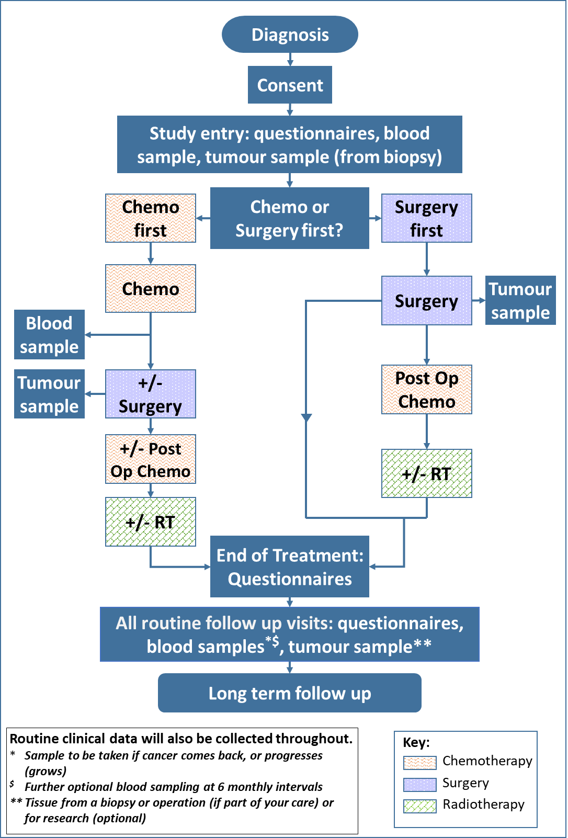

Samples schedules
Samples schedule:  If you are receiving surgery, with or without chemotherapy afterwards | Up to four weeks after registration | At Surgery | End of Treatment | Follow ups | If you have a local recurrence or metastases
Germline DNA Blood sample | Yes
ctDNA blood sample - Optional | Yes |  | Yes | Yes ¹ | Yes
FFPE tumour tissue sample | Yes | Yes |  |  | Yes²
Frozen tissue samples |  | Yes |  |  | Yes²
- Will be collected at clinic visits during follow up - no more than 6 monthly.
- Will only be taken if you consent to this optional biopsy (if this is not collected as part of your treatment).

Samples schedule:  If you are receiving chemotherapy before surgery | Up to four weeks after registration | During Treatment |  | End of Treatment | Follow ups | If you have a local recurrence or metastases
 |  | At the end of Neoadjuvant chemo | At Surgery
Germline DNA Blood sample | Yes
CTC blood sample | Yes | Yes | (Yes)¹ |  |  | Yes
ctDNA blood sample - Optional | Yes | Yes | (Yes)¹ | Yes | Yes² | Yes
PBMCs blood sample (UCLH patients only) | Yes | Yes | (Yes)¹ | Yes |  | Yes
FFPE tumour tissue sample | Yes |  | Yes |  |  | Yes³
Frozen tissue samples | Yes |  |  |  |  | Yes³
- Will be collected before surgery - if not taken at end of the chemotherapy before surgery
- Will be collected at clinic visits during follow up - no more than 6 monthly.
- Will only be taken if you consent to this optional biopsy (if this is not collected as part of your treatment).

Your treatment team’s contact details
Your doctor’s name:
Phone number:
Your research/ specialist nurse’s name:
Phone number:

Questions/Comments
The space below is for you to write down any questions you would like to ask your Doctor or Research Nurse about taking part in the study

