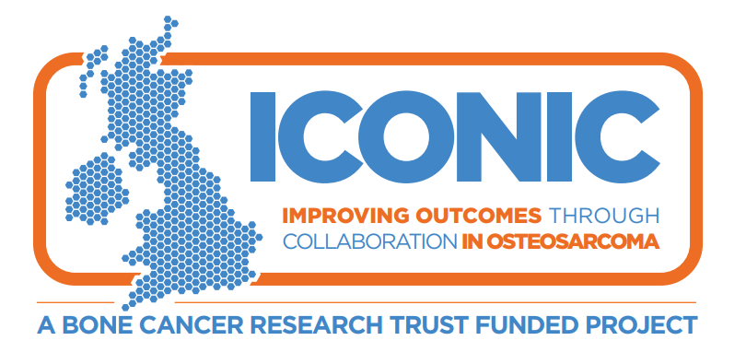
GP LETTER

[Insert date]
Dear Dr ___________________________
Patient Name: ________________________________ DOB: ____/____/____
Address: __________________________________________________________
___________________________________________________________________
ICONIC: Improving outcome through Collaboration in OsteosarComa

The ICONIC study is being funded by The Bone Cancer Research Trust (BCRT). It is sponsored by University College London and is being run by the Cancer Research UK & UCL Cancer Trials Centre.

This observational study involves collecting blood and tissue samples together with diagnostic imaging and high quality clinical data from patients diagnosed with Osteosarcoma. No treatments are specified in this research and patients will be treated as per standard of care. The goal of our research is to better understand variation in treatment of patients and investigate the molecular characteristics of this disease via a number of research platforms to develop better treatment strategies for patients.

As a part of the study we will be asking that GPs complete an ‘Osteosarcoma Primary Care Questionnaire’. Your participation will help us to gather valuable data to better understand the patient pathway from diagnosis of osteosarcoma and subsequent treatments to identify how to make this process more efficient and effective. The questionnaire is attached together with an accompanying information sheet which provides further details.

Your patient will be followed up for at least 2 years from registration. Should this patient fail to attend hospital clinic appointments you may be contacted for information on their current health status.
If you have any questions concerning the patient’s participation in this study, please contact myself or one of the Research Nurses/other contact, on:

Tel ........................................................………… or bleep ..................................................

_____________________________________
Consultant [amend as necessary]

Tel ........................................................………… or bleep ..................................................

_____________________________________
Research Nurse

Please ensure that a copy of this letter is kept in the patient’s file at your practice and that the patient is flagged as taking part in a clinical trial.

Yours sincerely

[Signed by Investigator at site]
[insert Investigators name and position]

Encs. ICONIC Patient Information Sheet
ICONIC early diagnosis GP questionnaire
ICONIC early diagnosis GP information sheet

