(INSERT HOSPITAL/INSTITUTION LOGO HERE)

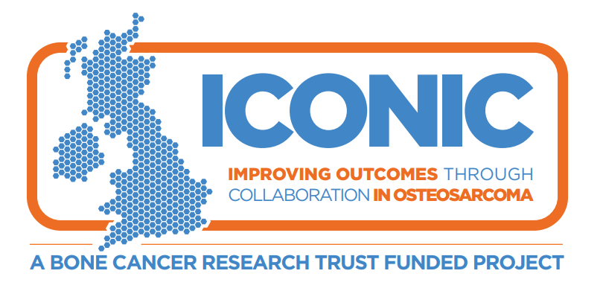

Information for consultees about a research study

Consultee Introduction
We feel your relative/friend is unable to decide for himself/herself whether to participate in this research.

To help decide if he/she should join the study, we’d like to ask your opinion on whether or not they would want to be involved. We ask you to consider what you know of their wishes and feelings, and to consider their interests.

- Please let us know of any advance decisions they may have made about participating in research. These should take precedence.

If you decide your relative/friend would have no objection to taking part we will ask you to read and sign the Consultee Declaration Form. We’ll then give you a copy to keep. We will keep you fully informed during the study so you can let us know if you have any concerns or you think your relative/friend should be withdrawn.

If you decide that your relative/friend would not wish to take part it will not affect the standard of care they receive in any way.

If you are unsure about taking the role of consultee you may seek independent advice, by contacting the Patient Advice and Liaison Service on [hospital to add local details].

We will understand if you do not want to take on this responsibility.

The following information is the same as would have been provided to your relative/friend.

Summary
We are asking your relative/friend to join this research study because he/she has recently been diagnosed with osteosarcoma or a similar bone cancer. We understand that this may be a very challenging time for you and your relative/friend but were wondering whether you would be interested in helping us better understand treatments for people in your relative/friend’s situation. We are committed to learning more about osteosarcoma so that we can develop new treatments and design better clinical trials to test for new treatments. Ultimately our aim is to help osteosarcoma patients live better and longer lives.

This study is simply observational so we are not testing any new treatments as such there will be no change to the standard treatment your relative/friend receives. For this study we would like to:
- collect clinical information about your relative/friend’s diagnosis and treatment for osteosarcoma by accessing their medical records
- collect blood samples and tumour tissue samples at selected time points as detailed below
- with your help, ask your relative/friend to complete some questionnaires at selected time points
- ask them to take a genetic test

Genetic testing is an important aspect of the study, so that we can look at the role that genetics play in responding to different treatments. If you decide your relative/friend would not want to have any genetic testing, they cannot take part in the study. There is more information about what is involved in taking part later in this Information Sheet.

Whilst your relative/friend may not benefit directly from this research, their participation may help patients in the future by improving treatments of osteosarcoma.

To help you understand why this study is important so that you can decide whether your relative/friend would have no objection to taking part, we have put together this information which may help you make a more informed decision. We would encourage you to please take time to read the information carefully and talk to your relative/friend and perhaps others about the study if you want.

We hope you will find this information sheet helpful, but we understand it may not answer all your or your relative/friend’s questions. We are here to help you both so please don’t hesitate to call us on the phone number at the end of this information sheet.

We are inviting your relative/friend to take part in a research study
- You are free to decide whether your relative/friend would have any objection to taking part in this research study. If you decide that your relative/friend would not wish to take part it will not affect the standard of care they receive in any way. If you decide your relative/friend would have no objection to taking part we will ask you to read and sign the Consultee Declaration Form.
- You or your relative/friend can decide that he/she no longer wants to take part in the study at any time without giving a reason.

Why are we conducting this research study?
- We want to understand more about what causes osteosarcoma and how osteosarcoma changes with treatment and over time. This will help us to decide what types of treatment are likely to work best, allowing us to develop better clinical trials of new treatments.
- Ultimately our aim is to help osteosarcoma patients to live better and longer lives.

Important things you need to know about this research study
- This is an observational study.
It is not a study looking at a new treatment. Taking part in this study will not stop your relative/friend from taking part in a study of a new treatment if this is an option for them.
- For our study we will take extra blood samples at up to 12 different times in addition to your relative/friend’s routine blood tests. Where possible, we will take these when your relative/friend has their routine bloods so no additional visits should be required.
- We will ask you to complete some questionnaires for your relative/friend about their health and wellbeing. This is something that he/she would not need to do if they were not on the study.

Will your relative/friend have to visit hospital more often if they take part?
- Your relative/friend does not have to make any extra visits to the hospital if they take part in this study.

Thank you
- Thank you for reading this information.
If your relative/friend takes part, they
will help us understand more about osteosarcoma and its treatment and
this may help future people with osteosarcoma.

Contents

1. Why are we doing this study? 4
2. Why are we asking your relative/friend to take part? 5
3. What will happen if your relative/ friend takes part? 5
4. Are there any risks? 7
5. What are the possible advantages and disadvantages of taking part? 7
6. Does your relative/friend have to take part? 8
7. How will your relative/friend’s information be used – will it be kept confidential? 8
8. Who is organising and funding the research? 8
9. Who has reviewed the study? 8
10. How will your relative/friend’s data be handled during the study? 9
11. Who will your relative/friend’s study data be shared with? 9
12. What will happen to the samples your relative/friend gives? 9
13. Will any genetic tests be done? 10
14. How long will the study last? 10
15. What will happen if you decide that your relative/friend would not wish to carry
on with the study? 10
16. What if there is a problem? 10
17. What will happen to the results of the research study? 11
18. Study Flowchart 13
19. Samples schedules 14
20. Your treatment team’s contact details 15

Why are we doing this study?
There hasn’t been much improvement in outcome for patients with osteosarcoma in over 20 years. There have been only a few clinical trials of new treatments and no major new therapies introduced recently.
This is in part because we do not have a good understanding of the biology of osteosarcoma, but also trials have only included small numbers of patients. The more we understand about how and why osteosarcoma happens, the better we will be able to decide what treatments are most likely to work best.
We are doing this study to collect high quality clinical data about osteosarcoma patients of all ages, such as information about the size of the disease and where it is at diagnosis, what treatments were given and how osteosarcoma responds to treatments. We will also collect blood and tissue samples for analysis in research laboratories.
By looking at the results of the laboratory findings and the clinical data together, we will start to answer questions about why osteosarcomas happen, what makes them spread and why some patients respond to treatment better than others.
We plan to use this information to develop clinical trials of new treatments.
Also, we want to find out more about how osteosarcoma and its treatments affect the lives of people with osteosarcoma. This will help us provide the most appropriate care and support to meet the needs of each patient.
Ultimately, our aim is to improve the care and treatment of osteosarcoma patients so that they may live longer and better lives.

Why are we asking your relative/friend to take part?
Your relative/friend has been invited to take part in this study because they have had a recent diagnosis of osteosarcoma.
We want to recruit as many patients to the study as possible and are recruiting patients of all ages from hospitals across the UK.
We hope to have at least 350 patients at the end of the study and we will be recruiting for around two more years.

What will happen if your relative/ friend takes part?

Treatment
If you decide your relative/friend would have no objection to taking part in this study, they will receive routine treatment for their osteosarcoma. Depending on their treatment plan, they may have one or more of the following:
- Surgery
- Chemotherapy
- Radiotherapy
As part of their routine care, we will explain what treatment they will receive. Your relative’s/friend’s treatment will not be affected by taking part in this study.

Tests and investigations
Your relative/friend will have all the routine tests and investigations that they would have even if they weren’t taking part in this study. These include blood tests, scans and biopsies if required.
If your relative/friend takes part, they will have some extra tests and investigations. These are described below. The number and timing of extra samples will depend on their treatment pathway.
If your relative/friend is part of this study we will monitor them at least annually according to routine practice for up to two years. After this we may continue to collect routine clinical data from their medical records (long term follow up) but they won’t need to attend any study specific visits for this.
We have a flow chart showing the different treatment pathways for osteosarcoma at the end of this information sheet.

Blood Samples
We will always aim to take study samples at the same time your relative/friend is having routine blood samples so no extra needles are required.
Germline DNA: We will take one blood sample to look at your relative/friend’s genome – this is the complete set of all their genetic code - so we can find patterns in their genes that are linked to their osteosarcoma
Circulating Tumour Cells (CTCs): We will take these blood samples if your relative/friend is having chemotherapy before surgery. CTCs are cells that break off from the tumour into the blood stream and we want to look to see if we can identify these cells in blood and use them to monitor how osteosarcoma patients respond to treatment.
We will take these samples at the following time points:
- Before your relative/friend starts chemotherapy,
- After chemotherapy, before your relative/ friend has surgery (if this is part of their treatment).
- If your relative/friend’s cancer comes back or spreads after treatment.
Circulating Tumour DNA (ctDNA): With your consent we will take these samples to look at the DNA released from tumour cells into the blood stream, to see if we can link it to how patients with osteosarcoma respond to treatment.
We will take these samples at the following time points:
- Before, or shortly after, your relative/ friend starts their chemotherapy.
- After chemotherapy, before they have surgery (if this is part of their treatment)
- At the end of your relative/friend’s treatment,
- Routine follow up clinic visits, no more than 6 monthly, after that.
- If your relative/friend’s cancer comes back or spreads after treatment.
These would be optional so if you consider that it is not appropriate for your relative/friend to give these blood samples they will not be taken.
[UCLH to include the following blue text. All other sites to delete]
Peripheral blood mononuclear cells (PBMCs): These cells are part of your immune system and are primed to recognise and destroy cells which do not belong to you. If you consent we will take these samples for immune studies and to see if we can link them to how osteosarcoma patients respond to treatment.
We will take these samples at the following time points:
- Before, or shortly after, your relative/friend starts their chemotherapy
- After chemotherapy, before they have surgery
- At the end of their treatment
- If your relative/friend’s cancer comes back or spreads after treatment.
We will collect these additional blood samples in about 20 patients taking part in the ICONIC study.
These will be optional so you do not have to give permission for these blood samples if you feel your relative/friend would not want to.
Over the course of the study we may take bloods at up to 12 time points. In total, this will be about 200mL of blood.
The amount of blood that we take will not affect your relative/friend in any way.
We would also like your consent to store any remaining blood samples for use in future research, but you do not have to consent to this you feel your relative/friend would not want to.

Tissue samples and biopsies
We will collect tissue samples for use in this research at the time of your relative/friend’s diagnosis and at their surgery. The tissue will be removed during routine procedures so he/ she will not have to have any extra procedures for this.

Questionnaires
We will ask your relative/friend (with your
help if appropriate) to complete some questionnaires about their symptoms, diagnosis, health and general wellbeing. It should take no more than 40 minutes to complete all the questionnaires. We will give the questionnaires:
- At study entry
- At the end of treatment (not applicable if treatment not given for any reason)
- At 12, 24, 36 and 48 months.
We will ask your relative/friend (with your help if appropriate) to complete a separate questionnaire shortly after they start treatment. This questionnaire aims to gain a better understanding of their pathway from symptoms and diagnosis to treatment for people with osteosarcoma. If you agree to complete these with your relative/friend, they will help us see changes in quality of life due to osteosarcoma, research into osteosarcoma patient experiences and look into the process of diagnosis for osteosarcoma. In addition, if you decide your relative/friend would have no objection, we will also ask their GP to complete a parallel questionnaire.

Data collection
If you decide your relative/friend would have no objection, we will collect data from their medical records about their general health, their cancer, their treatment and investigations including routine blood tests and scans. We will pass this information on to Cancer Research UK & UCL Cancer Trials Centre (UCL CTC), which is the organisation running the study. See Section 7 for more information about how his/her data will be handled.

Scan images
We would like to collect the images from any routine scans your relative/friend has, such as CT, MRI or bone scans. They will be sent to a team at UCL. We will use these to learn more about the different types of scans patients across the UK are having to diagnose their osteosarcoma. We will see if we can learn more about osteosarcoma by linking the information from these scans to the results from your relative/friend’s blood and tissue analyses and data collected from their medical records.
Only your relative/friend’s initials and study number will be marked on any scan images sent. This is to make sure that it will not be possible to identify them and make sure their scan images are not mixed up with those from other patients. The researchers will make sure their information is held securely and not shared with anyone else. See Section 10 below for more information in how their data is handled.

Are there any risks?
Taking part in this study will not entail any further risks for your relative/friend beyond those associated with routine treatment and blood sampling.

What are the possible advantages and disadvantages of taking part?

Advantages
Your relative/friend will not benefit directly from taking part in this study. However, by taking part, he/she will help us to understand more about osteosarcoma, and this may help future patients.

Disadvantages
There are very few disadvantages to taking part. Your relative/friend may need to spend a bit of extra time at the hospital when he/she visits for their appointments to complete the study questionnaires or have the extra blood tests.

Does your relative/friend have to take part?
No.
We will go through this information sheet with you and answer any questions that you have. If you decide your relative/friend would have no objection to taking part we will ask you to read and sign the Consultee Declaration Form.
We will keep you fully informed during the study, so you can let us know if you have any concerns or think your relative/friend should be withdrawn from the study, without giving a reason. This will not affect the standard of care your relative/friend receives.

How will your relative/friend’s information be used – will it be kept confidential?
University College London (UCL) is the Sponsor and Data Controller for this study and it is run on their behalf by Cancer Research UK & UCL Cancer Trials Centre (UCL CTC), based in
the United Kingdom. UCL CTC will be using information from your relative/friend and their medical records to undertake this study. This means that UCL CTC are responsible for looking after your relative/friend’s information and using it properly. UCL CTC will keep identifiable information about them for at least 5 years after the study has finished.
Details about your relative/friend and their treatment and how the cancer responds will
be recorded in his/her medical notes. This research is conducted in the public interest as it may lead to improvements in future treatment.
Your relative/friend’s rights to access, change or move their information are limited, as UCL CTC need to manage their information in specific ways so that the research is reliable and accurate. If your relative/friend is withdrawn from the study, UCL CTC will keep information about them that they have already obtained. To safeguard your relative/friend’s rights, UCL CTC will use the minimum personally identifiable information possible.
You can find out more about how UCL CTC will use your relative/friend’s information on UCL CTC’s website:
https://www.ctc.ucl.ac.uk/Privacy.aspx
If you want to raise a complaint on how UCL CTC have handled your relative/friend’s personal data, you can contact UCL’s Data Protection Officer who will investigate the matter. If you are not satisfied with their response or believe they are processing your relative/friend’s personal data in a way that is not lawful you can complain to the Information Commissioner’s Office (ICO).

UCL’s Data Protection Officer can be contacted on data-protection@ucl.ac.uk.

Who is organising and funding the research?
The study is funded by the Bone Cancer Research Trust (BCRT) a charity dedicated to fighting primary bone cancer. The study is being run by UCL CTC.
The hospital where your relative/friend will be treated will receive a payment to help cover the costs of this research (blood tests). However, your relative/friend’s doctor will not be paid for including him/her in this study.

Who has reviewed the study?
All research in the NHS is looked at by an independent group, called a Research Ethics Committee, to protect the interests of any patients who may take part. This study has been reviewed and granted a favourable opinion by the London – Camden and King’s Cross Research Ethics Committee (REC) and has also been approved by the Health Research Authority (HRA).

How will your relative/friend’s data be handled during the study?
When your relative/friend joins the study UCL CTC will assign them a study number, which will be used instead of their name and will be linked to all their study data. This is called ‘pseudonymised data’: your relative/friend cannot be directly identified from this.
We will also pass your relative/friend’s initials, age and sex to UCL CTC along with the information collected from your relative/friend and their medical records. Their initials and study number will also be marked on any blood samples, tissue samples, images and pathology reports that you decide they would have no objection to being collected and sent to laboratories analysing these samples in the UK as part of this study. This is to make sure that their samples are not mixed up with those from other patients. The laboratories will make sure your relative/friend’s information is held securely and not shared with anyone else.
Your relative/friend’s medical records may also be looked at by appropriate individuals from UCL CTC, UCL or its representatives, regulatory authorities and your NHS Trust or Health Board. This is to ensure that the study is being carried out properly and the information collected is accurate. The appropriate individuals may compare the recorded research data with your relative/friend’s health records. They might read your relative/ friend’s health records though a secure internet connection or at the hospital or clinic. All the computers storing patient data must meet special security arrangements.
Your relative/friend’s name or identifiable data will not be used in any reports about the study.

Who will your relative/friend’s study data be shared with?
If you decide your relative/friend would have no objection to taking part in this research study, the information about his/her health and care may be provided to researchers running other research studies in UCL and other organisations, such as universities, the NHS, or companies involved in health and care research in the UK or abroad. Your relative/ friend’s information will only be used in research that has been independently reviewed by an Ethics Committee and is conducted in accordance with the UK Policy Framework for Health and Social Care Research.

UCL CTC will not share any information that can identify your relative/friend, or that can be combined with other information in a way that could directly identify him/her, however we may share their study number. The information will only be used for the purpose of health care research and cannot be used to contact your relative/friend or affect their care. Information about your relative/friend will not be used to make decisions about future services available to them, such as insurance.

What will happen to the samples your relative/friend gives?

Blood and tissue samples collected for research
The blood and tissue samples collected for research will be sent to laboratories in the UK, and possibly outside the UK. They will be used for research to help scientists learn more about osteosarcoma. This includes trying to find ways to predict who is going to respond to treatment, understanding more about what causes osteosarcoma to grow and how the cells may change after treatment.

Future research
If you decide your relative/friend would have no objection to the storage of some of their tissue and blood samples for use in future research projects we will ask you to read and sign this part of the Consultee Declaration Form. Any future research that involves your relative/friend’s stored tissue or blood samples will take place only after it has received appropriate Ethical approval.
If you decide that your relative/friend would not wish to give permission for the use of their tissue and blood samples in future research, your relative/friend may still participate in this study.

Will any genetic tests be done?
Yes. Genetic testing is an important part of this research.
We will ask you to decide if your relative/friend would have no objection specifically to having genetic testing. If you decide your relative/ friend would not wish to have any genetic testing, he/she will not be able to take part in the study.
Results of genetic tests may include chance findings about your relative/friend’s health, or that of his/her blood relatives. For instance, the tests may show that your relative/friend has a genetic mutation putting them at greater risk of developing another cancer, and that their blood relatives could have this mutation as well.
You should decide if your relative/friend and their blood relatives would wish to know about any chance findings and sign the appropriate section of the Consultee Declaration Form.
However, we will always tell you and your relative/friend about any findings that could affect the way we treat his/her cancer.
If we do tell you and your relative/friend about a chance finding, where appropriate we will refer you and your relative/friend (and their family if necessary) to a genetic counsellor who will give information and advice.

How long will the study last?
This study has approval to last for two years.
If further funding becomes available after this time we would like to continue to collect your relative/friend’s routine clinical data. We would pass this to UCL CTC.
This means your relative/friend’s participation in the study will be from the time they enter the study until the time the study ends: up to two years but possibly longer if the study is extended.

What will happen if you decide that your relative/friend would not wish to carry on with the study?
If you decide your relative/friend does not want to take part he/she can be withdrawn from the study at any time without giving a reason and without their rights being affected, but UCL CTC would like to continue collecting information about their health from their hospital. If you or your relative/friend do not want this to happen, tell us and we will stop. They will also use the information collected up to your relative/friend’s withdrawal.
Any stored blood or tissue samples that can be identified as your relative/friend’s will be destroyed If you decide that he/she would not want them to be kept.

What if there is a problem?
Every care will be taken in the course of this study. However, in the unlikely event that your relative/friend is injured by taking part, compensation may be available.
If you suspect that the injury is the result of the Sponsor’s (University College London) or the hospital's negligence, then you may be able to claim compensation. After discussing with your relative/friend’s study doctor or another doctor if you would prefer, please make the claim in writing to Dr Sandra Strauss, who is the Chief Investigator for the study, and is based at University College London, c/o ICONIC Trial, Cancer Research UK & UCL Cancer Trials Centre, 90 Tottenham Court Road, London, W1T 4TJ. The Chief Investigator will then pass the claim to the Sponsor and on to the Sponsor’s Insurers. If you have a claim then it might be helpful to consult a lawyer.
Participants may also be able to claim compensation for injury caused by participation in this study without the need to prove negligence on the part of University College London or another party. You should discuss this possibility with your relative/ friend’s study doctor in the same way as above.
Regardless of this, if you want to complain or have any concerns about any aspect of the way your relative/friend has been approached or treated by members of staff due to his/her participation in the study, the normal National Health Service complaints mechanisms are available to you. Please ask your relative/ friend’s study doctor if you would like more information on this. Details can be obtained from the NHS website.

What will happen to the results of the research study?
The results of the study will be published in medical journals. Your relative/friend’s identity and any personal details will be kept confidential. No named information about your relative/friend will be published in any report of the study. Once the results of the study have been published they will also be available to the public on the internet.
We will have a summary of the results which we can give to you or your relative/friend’s family and carers. We would also be happy to explain the results of the study to you and your relative/friend and to answer any questions you and he/she have.

Thank You
Thank you for taking the time to read this leaflet and to consider this study.
Please discuss any questions you or your relative/friend may have with us. Contact details are given at the end of this information leaflet if you would like to discuss any aspect of the study further. There is also space at the end of the Consultee Information Sheet for you to write down questions/comments that occur to you as you read about the study.

Further Information
You may wish to contact one of the following organisations that are independent of the hospital where your relative/friend is being treated:

Cancer Research UK
Cancer Research UK provides information for people with cancer. Their contact details are:
Freephone: 0808 800 4040 (Mon-Fri 9am-5pm)
Or visit their website at:
https://www.cancerresearchuk.org/about-cancer

Macmillan Cancer Support
Macmillan is a charity which provides support and counselling to help people live with cancer. They can be contacted at:
Freephone: 0808 808 0000 (8am-8pm, seven days a week)
https://www.macmillan.org.uk/information-and-support

Bone Cancer Research Trust
The Bone Cancer Research Trust is the leading charity dedicated to fighting primary bone cancer. Their mission is to save lives and improve outcomes for people affected by primary bone cancer through research, information, awareness and support.
https://www.bcrt.org.uk/information/

If you decide your relative/friend would have no objection to taking part we will ask you to read and sign the Consultee Declaration Form. We’ll then give you a copy to keep. You and your relative/friend can have more time to think this over if you are at all unsure.

Study Flowchart

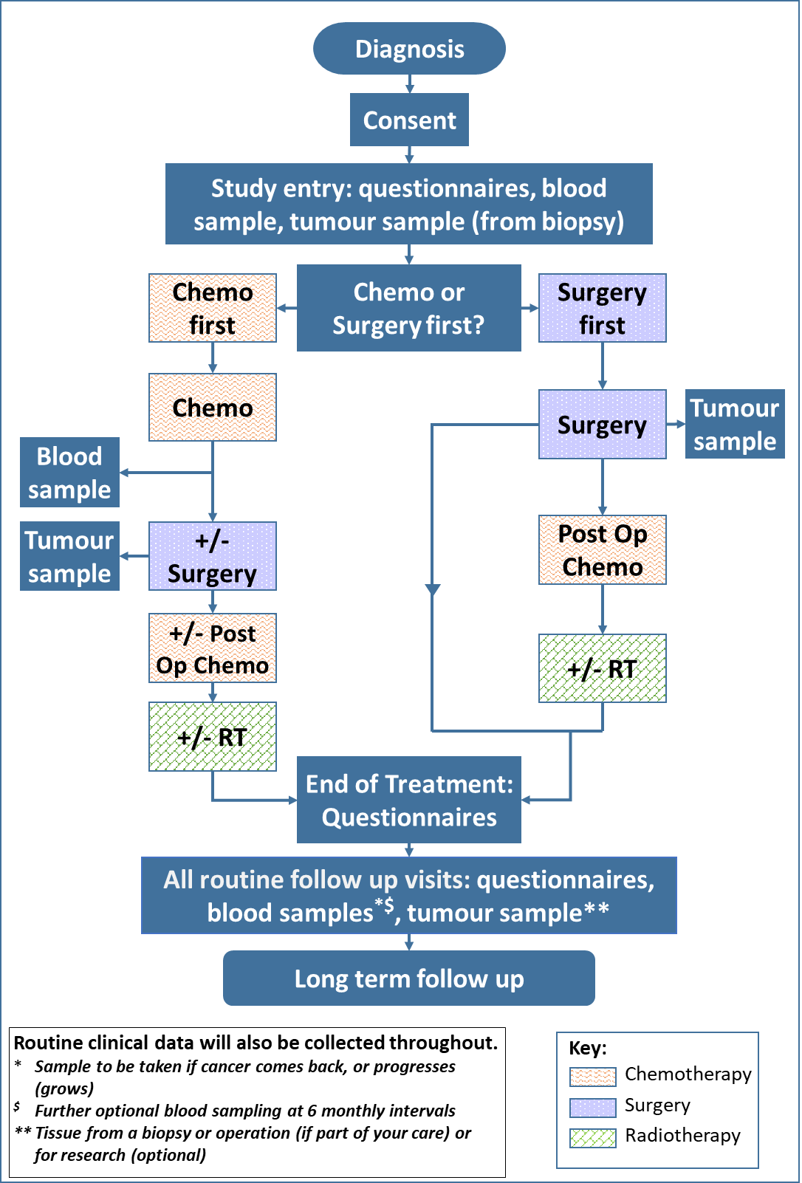

Samples schedules
Samples schedule:  If your relative/friend is receiving surgery, with or without chemotherapy afterwards | Up to four weeks after registration | At Surgery | End of Treatment | Follow ups
Germline DNA Blood sample | Yes
ctDNA blood sample - Optional | Yes |  | Yes | Yes ¹
FFPE tumour tissue sample | Yes | Yes
Frozen tissue samples |  | Yes
- Will be collected at clinic visits during follow up - no more than 6 monthly.

Samples schedule:  If your relative/friend is receiving chemotherapy before surgery | Up to four weeks after registration | During Treatment |  | End of Treatment | Follow ups
 |  | At the end of Neoadjuvant chemo | At Surgery
Germline DNA Blood sample | Yes
CTC blood sample | Yes | Yes | (Yes)¹
ctDNA blood sample - Optional | Yes | Yes | (Yes)¹ | Yes | Yes²
PBMCs blood sample (UCLH patients only) | Yes | Yes | (Yes)¹ | Yes
FFPE tumour tissue sample | Yes |  | Yes
Frozen tissue samples | Yes
- Will be collected before surgery - if not taken at end of the chemotherapy before surgery
- Will be collected at clinic visits during follow up - no more than 6 monthly.

Your treatment team’s contact details

Your relative/friend’s doctor:
Phone number:
Your relative/friend’s research/specialist nurse:
Phone number:

Questions/Comments
The space below is for you to write down any questions you would like to ask your relative’s/friend’s Doctor or Research Nurse about taking part in the study.

