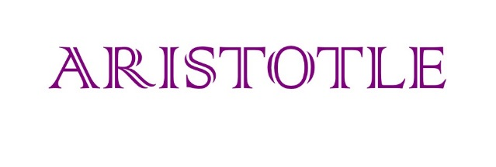

**HOW TO DOWNLOAD & EXTRACT TRIAL DOCUMENTS**

All essential documents, including protocol, PIS, ICF, approval letters and CRFs are available via the UCL CTC website; however, you need a password to open these documents.

**Single Document:**

To access password protected documents directly from the website, please enter the password provided by the ARISTOTLE team (password is case sensitive/all lower case).

**Zip Folder:**

Documents are filed on the website in the order they appear in the ISF.

To save a copy of all files within each zip folder to a central location (without need to re-enter password to access each document), please follow the following procedure:

1. Download document from website (cid:image005.jpg@01D2D2E9.26F29250)
2. Save a copy of the relevant Zip folder to an appropriate location (i.e. desktop) OR view Zip folder in “Downloads” folder
3. Right click on (copied) Zip folder
4. Select “Extract All” from list
5. Select a destination to save the extracted folder
6. Click “Extract”
7. Add password (please contact the ARISTOTLE team if you require the password)
8. Open extracted folder – all files should now be accessible without the need to enter a password to open

**Contact Information:**

If you have any questions about the website or are unable to locate documents, please do not hesitate to contact the ARISTOTLE trial team: [ctc.aristotle@ucl.ac.uk](mailto:ctc.aristotle@ucl.ac.uk).