- Click on the file download
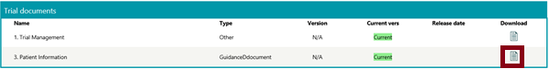
- Choose “Save As”
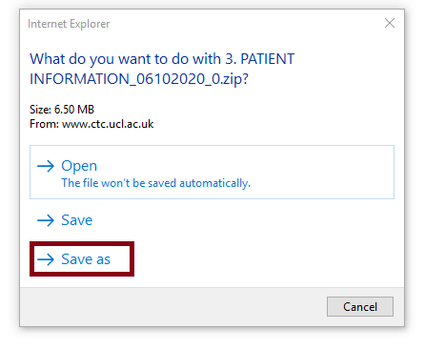
- Choose an appropriate place to save the file and press “Save”.
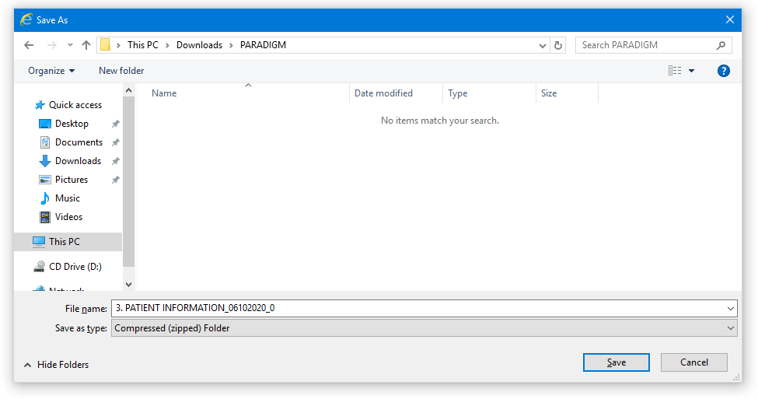
- Press “Open Folder”.
- The zip file now needs to be extracted the password entered.

If, however you receive the following error message :
‘Compressed (zipped) folders error
Windows cannot complete the extraction
The destination file could not be created.’

Delete the previous download first from the saved folder.
Then re-download again and ‘Save as…’
Do the following after it has been ‘Saved As…’ Do not attempt to un-zip or open the zipped folder

- Go to the place where the zipped folder has been saved
- Right click on the zipped folder and select 7-Zip > open archive

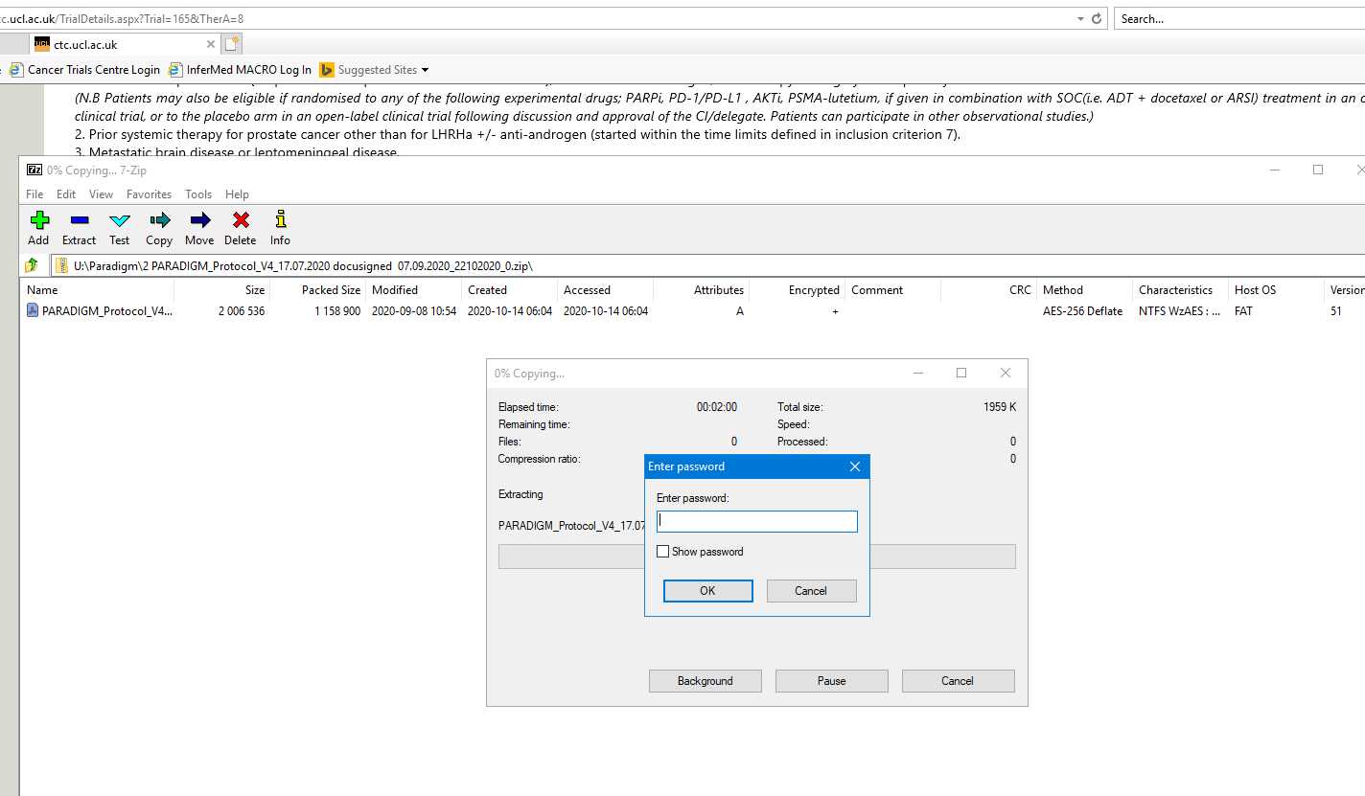
- Double click on the document(s) that appear and then enter the password in the pop-up box.

